NEAR-FUTURE HARD SCI-FI
UI/UX Style Guide
Synthesized from The Martian · The Expanse · Project Hail Mary
KSA-Bridge Sample Library Reference · v2.0 · April 2026
Includes: Icon Libraries · Typography System · Reusable Component Catalog

COPYRIGHT, ACKNOWLEDGMENTS & NOTICES

This Document
KSA-Bridge UI/UX Style Guide v3.0 © 2026 John M. Knight. Created as part of the KSA-Bridge open source project. This document may be reproduced and adapted freely within the scope of the KSA-Bridge project and its sample library. Attribution is appreciated but not required for open source derivative works.
Referenced Film & Television Properties
This document analyzes the fictional user interface design of three copyrighted works for educational and design reference purposes. All rights in the referenced films and television series remain with their respective owners. This guide is not affiliated with, endorsed by, or connected to any of the studios, production companies, or design firms named herein.
The Martian (2015)
Film directed by Ridley Scott. Based on the novel by Andy Weir (© Andy Weir, 2011). The Martian © 2015 Twentieth Century Fox Film Corporation. All rights reserved. User interface and screen graphics designed by Territory Studio, London. Creative Director: David Sheldon-Hicks. Motion Graphics Art Director: Marti Romances. Lead CGI: Peter Eszenyi. Design and Animation: Daniel Højlund, Marti Romances, Sam Keehan. Producer: Sam Hart. Territory Studio retains all intellectual property rights in their original graphic design work. Any analysis of their work in this document is made under fair use for educational and design research purposes.
The Expanse (2015–2022)
Television series produced by Alcon Entertainment and Amazon Studios. Based on the novels by James S.A. Corey (Daniel Abraham and Ty Franck). The Expanse © Alcon Entertainment, LLC. All rights reserved. User interface and screen graphics: Season 1 designed by Timothy Peel, Junction Box Design Studio. Seasons 3 and 5 motion graphics by Rhys Yorke, Sumeet Vats, Victor Mare, Chris Ouimet, Robert Nowacki, Walter H. May, Colin Graham, and Nick Melia. Showrunner: Naren Shankar. All FUI designers retain creative attribution for their individual contributions. Analysis in this document is made under fair use for educational and design research purposes.
Project Hail Mary (2026)
Film directed by Phil Lord and Christopher Miller. Based on the novel by Andy Weir (© Andy Weir, 2021). Project Hail Mary © 2026 Amazon Content Services LLC. All rights reserved. Visual effects supervised by Paul Lambert and Mag Sarnowska. Visual effects by Industrial Light & Magic and Framestore. Production design by the film's art department. Analysis in this document is made under fair use for educational and design research purposes.
Reference Images (Section 14)
The reference images in Section 14 of this document were generated using ChatGPT with image generation (OpenAI, o1 model) from detailed prompts derived from the style guide specifications. These are wholly AI-generated images created as interpretive design references. They are not screenshots, frame grabs, digital reproductions, or derivative works of any copyrighted film, television, or graphic design material. No copyrighted imagery was used as input. These images are included for internal design reference and inspiration within the KSA-Bridge open source project.
Open Source Components Referenced
The following open source libraries are recommended in this guide. Each is subject to its own license terms:
Lucide Icons — ISC License — Copyright © 2020 Lucide Contributors — lucide.dev
Phosphor Icons — MIT License — Copyright © 2020 Phosphor Icons — phosphoricons.com
Tabler Icons — MIT License — Copyright © 2020 Paweł Kuna — tabler.io/icons
JetBrains Mono — SIL Open Font License 1.1 — Copyright © 2020 JetBrains — jetbrains.com/lp/mono
IBM Plex — SIL Open Font License 1.1 — Copyright © 2017 IBM Corp — ibm.com/plex
Google Fonts (VT323, Share Tech Mono, Exo 2, Rajdhani, Chakra Petch, Barlow Condensed, Orbitron, Courier Prime) — SIL Open Font License — fonts.google.com
Chart.js — MIT License — Copyright © 2014 Nick Downie — chartjs.org
Research & Analysis Acknowledgments
This document draws on analysis and interviews published by the following sources. All cited works remain the intellectual property of their respective authors and publishers:
Territory Studio — The Martian project documentation and interviews — territorystudio.com
Pushing Pixels (Kirill Grouchnikov) — Interviews with Marti Romances, David Sheldon-Hicks, and Timothy Peel (2016) — pushing-pixels.org
AWN / VFXWorld — "Interfacing with Mars: Territory Studio and The Martian" (November 2015) — awn.com
HUDS+GUIS (Jono Yuen) — The Martian UI Design analysis (2015) and The Expanse UI Design with Rhys Yorke interview (2021) — hudsandguis.com
Fuzzy Math — "Sci-Fi UI: What Three Spaceships Can Teach Us About the Future of User Interfaces" (2025) — fuzzymath.com
Sci-Fi Interfaces (Christopher Noessel) — Q&A with Territory Studio (2020) — scifiinterfaces.com
Ars Technica (Lee Hutchinson) — "Apollo Flight Controller 101: Every Console Explained" (2012 / 2019 reprint) — arstechnica.com
NotebookCheck (Anubhav Sharma) — "Project Hail Mary makes a strong case for physical buttons in tech" (March 2026) — notebookcheck.net
Hackster.io — "Recreating a Cockpit Control Console From Project Hail Mary" (March 2026) — hackster.io
Fonts in Use — The Martian UI Graphics typeface documentation — fontsinuse.com
ArtStation — Rocinante UI design documentation by multiple contributors across Expanse seasons — artstation.com
Fair Use Notice
This document contains analysis and discussion of copyrighted film and television productions for the purposes of education, criticism, and design research. Such use is made under the fair use doctrine (17 U.S.C. § 107) and equivalent provisions in other jurisdictions. No copyrighted visual material from any referenced production has been reproduced in this document. All trademarks, service marks, and trade names are the property of their respective owners and are used herein for identification and reference purposes only.
KSA-Bridge Project
KSA-Bridge is an open source MQTT telemetry bridge for Kitten Space Agency. This style guide is part of the KSA-Bridge Sample Library, which provides reference implementations for consuming KSA-Bridge telemetry data in various display styles.
Repository: github.com/johnmknight/KSA-Bridge
Author: John M. Knight · Florida, USA · April 2026

1. Overview & Design Philosophy
This guide synthesizes the visual and interaction design language of three landmark works of near-future hard science fiction: Territory Studio's UI work for The Martian (2015), the motion graphics team's work on The Expanse (2015–2022), and the production design of Project Hail Mary (2026). All three share a common philosophical foundation that distinguishes them sharply from mainstream science fiction interfaces.

The Core Principle
These are not fantasy interfaces. They are engineering tools. Every visual decision should emerge from the question: how would a trained operator working under time pressure in a safety-critical environment actually need this information presented?

The three sources differ significantly in their specific aesthetics and eras, but converge on a set of shared principles that form the backbone of this guide.

1.1 The Near-Future Design Mandate
Territory Studio's creative director David Sheldon-Hicks described the central question for The Martian as: "What would NASA's computer user interfaces look like 20 years from now?" This frames the entire philosophy. Near-future design means:
- Grounded in current engineering logic, not imagined future technology
- Evolved from today's systems — recognizable, not alien
- Real constraints drive real design decisions: radiation limits display brightness; gravity orientation changes layout logic; gloved hands change minimum touch target size
- Authenticity is non-negotiable: all three productions consulted actual aerospace engineers, NASA personnel, or hard science literature

1.2 Source Comparison
 | The Martian | The Expanse | Project Hail Mary
Year | 2015 | 2015–2022 | 2026
Design Team | Territory Studio (Romances, Sheldon-Hicks) | Timothy Peel / Rhys Yorke / Sumeet Vats | Lord & Miller (practical production design)
Time Setting | ~20 years from now | 200 years from now | Near future
Design Approach | Context-specific languages, NASA collaboration | Faction-differentiated, integrated ecosystem | Physical-first, tactile, anti-touchscreen
Key Aesthetic | Functional restraint, mathematical precision | Dark panels, spatial holographics, hard sci-fi | Used future, toggle switches, warm industrial

2. Core Design Principles

2.1 Data Before Decoration
Every visual element must serve information delivery. Territory Studio's Marti Romances described the Mission Control work as "extremely functional and all about systems, data, control, feedback and schematics." HUDS+GUIS noted The Martian "relies on typography, layout and minimal uses of colour to do the heavy lifting."
- No decorative gradients, lens flares, or animated chrome
- Icons used sparingly — only when they carry unambiguous meaning with no text label
- Small type used as atmosphere and technical texture, not decoration
- Every panel boundary, color zone, and separator exists to organize information

2.2 Context-Specific Visual Languages
All three works explicitly reject a single unified UI system. The Martian delivered four distinct visual languages within one film: Mission Control, Hermes spacecraft, HABitat, and JPL engineering. The Expanse differentiates Earth, MCRN, OPA, and Belter interfaces by culture and manufacturing resources.
Application Rule
For KSA-Bridge sample displays: resist applying one visual style to all displays. Mission Control looks different from a crew tablet, which looks different from a rover dashboard. Context drives design.

2.3 Physical / Digital Continuum
Project Hail Mary makes the most explicit statement: the Hail Mary spacecraft is covered in toggle switches, levers, guarded buttons, and rotary dials. The cockpit's tablet-sized screen is surrounded by physical controls. "Grace can keep his eyes on the Petrova Task data while his hand moves around to find the cooling system lever, freeing up one sense entirely."
- Critical functions: physical controls (toggles, levers, guarded buttons)
- Status monitoring: screens and displays
- Navigation and spatial mapping: holographic or large-format
- Personal data: tablet / handheld

2.4 Grid Discipline
Tight, mathematical grid alignment is visible throughout all three works. Territory Studio's Romances described "applying user architecture rules to make sense of the data." HUDS+GUIS noted The Martian "layout structures are neat and adhere to tight grids — it looks almost mathematical."

3. Color Systems

3.1 The Martian — Hermes / Mission Control
Blue, green, and white against black. Contemporary avionic feel, clear grid structure, data-dense.

Screen Black  #000C1A  Primary display background | Hermes Blue  #0066CC  Primary accent, data labels | Teal Active  #00CCAA  Active states, confirmed data
Data White  #FFFFFF  Primary data values | Dim Blue  #88AACC  Secondary labels, dim state | Panel Separator  #334455  Grid lines, panel borders

3.2 The Martian — HABitat / Research
Lighter environment. Modernist, research-facility feel. More approachable, less austere than the ship.

HAB White  #F0F4F8  Display background | Habitat Dark  #1A2A3A  Primary text | HAB Blue  #0088CC  Active elements
Panel Light  #E0E8F0  Secondary panels | Label Gray  #607080  Descriptive labels | Alert Orange  #CC4400  Warnings only

3.3 The Expanse — Rocinante / Ship Systems
Dark, functional, military-industrial. Designed for long-duration use under varied gravity conditions.

Roci Black  #0A1018  Ship display background | Deep Panel  #1A3050  Secondary panel fill | Tactical Blue  #00AAFF  Navigation, targeting
OPA Orange  #FF6B20  Alerts, OPA faction accent | Data Cyan  #80C0FF  Numeric readouts | Grid Line  #304050  Panel separators

3.4 Project Hail Mary — Hail Mary Ship
Warm, industrial, tactile. Well-worn amber and functional dark — not pristine. Physical materials drive the color language.

Ship Dark  #1A1208  Background for screens | Hail Amber  #C8882A  Primary text and data | Warm White  #E8D0A0  Active data values
Panel Warm  #3A2810  Secondary panel fill | Label Dim  #806040  Dimmed labels | Alert Red  #CC2200  Critical alerts only

3.5 Universal Status Colors
Reserved strictly for system state. Never used decoratively. Three states only — no extensions.

Nominal Green  #1A7A3A  NOM — within all parameters | Caution Amber  #A07800  CAUT — approaching limit | Alarm Red  #B52020  ALRM — limit exceeded, action required

4. Typography System

4.1 Typeface Selection by Context
Different environments use different typefaces — reflecting that real systems are built by different vendors at different times. The Martian confirmed this: Gridnik for Hermes/Mission Control, Trim for the HAB, Carbon for the Rover. Freely available web alternatives are listed below.

Context | Typeface | Availability | Source Reference | CSS Import
Apollo-era terminal | VT323 | Google Fonts (free) | Apollo console samples | font-family: "VT323"
Ship navigation / flight data | Share Tech Mono | Google Fonts (free) | Gridnik substitute | font-family: "Share Tech Mono"
Numeric readouts / data | JetBrains Mono | Google Fonts (free) | Technical monospace | font-family: "JetBrains Mono"
Mission Control data | IBM Plex Mono | Google Fonts (free) | Clean IBM-era monospace | font-family: "IBM Plex Mono"
Industrial section headers | Exo 2 | Google Fonts (free) | Condensed industrial sans | font-family: "Exo 2"
Condensed data labels | Rajdhani | Google Fonts (free) | Technical condensed | font-family: "Rajdhani"
Technical sub-headers | Chakra Petch | Google Fonts (free) | Futuristic technical | font-family: "Chakra Petch"
Utilitarian UI labels | Barlow Condensed | Google Fonts (free) | Martian HAB/JPL | font-family: "Barlow Condensed"
Atmospheric body | Courier Prime | Google Fonts (free) | Enhanced Courier analog | font-family: "Courier Prime"
Display headers (use sparingly) | Orbitron | Google Fonts (free) | Futuristic stylized | font-family: "Orbitron"

4.2 Google Fonts Import Block
Add this single import to the <head> of any KSA-Bridge sample page to load all recommended typefaces:

@import url('https://fonts.googleapis.com/css2?
family=VT323&
family=Share+Tech+Mono&
family=JetBrains+Mono:wght@400;500;700&
family=IBM+Plex+Mono:wght@400;500&
family=Exo+2:wght@300;400;500;600&
family=Rajdhani:wght@400;500;600&
family=Chakra+Petch:wght@400;500&
family=Barlow+Condensed:wght@300;400;500&
family=Courier+Prime&
family=Orbitron:wght@400;700
&display=swap');

4.3 CSS Custom Property System
Define these at :root to apply the correct typeface per context. All samples should use these variables rather than hardcoding font-family strings.

:root {
/* Typefaces by role */
--font-terminal: "VT323", monospace; /* Apollo-era samples */
--font-data: "JetBrains Mono", monospace; /* Numeric readouts */
--font-nav: "Share Tech Mono", monospace;/* Navigation data */
--font-label: "Barlow Condensed", sans-serif;/* Panel labels */
--font-header: "Exo 2", sans-serif; /* Section headers */
--font-technical: "Rajdhani", sans-serif; /* Sub-labels, units */
--font-display: "Orbitron", sans-serif; /* Display only (rare)*/

/* Type scale */
--text-xl: 18px; /* Primary data values */
--text-lg: 15px; /* Secondary labels */
--text-md: 13px; /* Standard body */
--text-sm: 11px; /* Units, descriptors */
--text-xs: 9px; /* Atmospheric texture type */

/* Letter spacing */
--track-tight: 0;
--track-normal: 0.03em;
--track-wide: 0.10em; /* ALL CAPS labels */
--track-xwide: 0.18em; /* Station IDs, titles */
}

4.4 All Caps & Letter Spacing Rules
Station labels, section headers, status indicators, and system identifiers use ALL CAPS with tracked letter-spacing throughout all three source works. This convention communicates official designation.
- System / station IDs: ALL CAPS, letter-spacing 0.10–0.18em
- Status indicators: ALL CAPS, no letter-spacing (NOM / CAUT / ALRM must read fast)
- Section headers: ALL CAPS, letter-spacing 0.08em
- Numeric values: mixed case or all-numeral — never caps
- Event log entries: ALL CAPS abbreviations (MECO, TLI, AOA, IHNB)

5. Data Display & Information Hierarchy

5.1 The Parameter Row Pattern
The fundamental unit of mission display design. Consistent across Apollo real screens, The Martian, and The Expanse: a labeled parameter with value, units, and status on a single horizontal line.

PARAMETER | VALUE | UNITS | Δ TARGET | STATUS
VELOCITY | 7,784.3 | M/SEC | +0.3 | NOM
ALT MSL | 207.4 | KM | +0.4 | NOM
PROP REMAIN | 252,977 | KG | — | CAUT

Standard parameter row. Monospace for numeric values. Delta column shows — when no target is defined.

5.2 Status Indicators
State | Symbol | Color Hex | Blinks | Use When
Nominal | ● NOM | #1A7A3A | No | All parameters within limits
Caution | ● CAUT | #A07800 | No | Approaching limit; no immediate action required
Alarm | ▲ ALRM | #B52020 | Yes — until acknowledged | Limit exceeded; action required now
No Data | ○ HOLD | #888888 | No | MQTT disconnected or sensor offline

6. Physical / Digital Interface Design

6.1 Control Hierarchy
Criticality | Control Type | Why
Critical / Emergency | Guarded physical toggle or dedicated key | Must be operable without looking
Primary Operations | Physical button / labeled key | Tactile confirmation of activation
Navigation / Selection | Touch screen or trackball | Flexibility outweighs tactile need
Data Query / Analysis | Touch or gesture | Speed and flexibility paramount
Configuration | Software menu | Infrequent; speed less critical

6.2 Glove-Compatible Touch Targets
- Minimum touch target: 16mm × 16mm for gloved operation (vs. 9mm for bare hand)
- Increased spacing between adjacent interactive elements — minimum 4mm clearance
- Physical controls preferred over touch for glove-intensive environments (EVA, engineering)
- High contrast and large text for visibility through helmet visors

7. Status & Alert Design
The three-state alert model (NOM / CAUT / ALRM) is inherited from real aerospace practice and is non-negotiable. Adding additional states dilutes the meaning of each.
- Alarms blink — cautions do not. Blinking draws attention to unacknowledged action items.
- Alarm indicator uses ▲ triangle symbol — distinct from ● used for nominal and caution.
- Multiple simultaneous alarms must appear in a dedicated alarm summary area.
- When data is absent (no MQTT), show ○ HOLD, not ● NOM. Missing data must never read as nominal.
- Time since last update should be visible when data is stale but connection is technically live.

8. Motion & Animation
Principle
Animation in mission display design serves one purpose: drawing attention to change. It is not decorative. Unnecessary motion in a high-attention environment increases cognitive load.

Animation Type | Appropriate | Rationale
Value update flash (brief highlight) | Yes | Operator needs to know a value changed
Alarm blinking (▲) | Yes — unacknowledged only | Distinguishes active alarm from acknowledged
Live clock / GET countdown | Yes | Time is always changing; static would be wrong
Rolling chart window | Yes | Operator needs to see trend over time
Page transitions / fades | No | No mission-critical information conveyed
Decorative shimmer / glow | No | Visual noise without information content
Loading progress indicator | Yes — known-wait operations only | Communicates system is not frozen

9. Environment & Context Differentiation

9.1 The Expanse Faction Model
Faction | Visual Character | Why
Earth / UN | Formal, layered, heavy data density, multiple simultaneous streams | Bureaucracy — data-rich, resource-abundant
MCRN (Mars) | Military precision, tight grid, tactical blue, minimal chrome | Military culture — function absolute
OPA / Tycho | Warm amber/orange accents, older hardware integrated, improvised | Resource-constrained, proud of engineering ingenuity
Belters | High-visibility overlays, hand-modified, worn | Working class, hostile environments, modified for specific tasks

9.2 KSA-Bridge Context Mapping
Display Context | Recommended Visual Language | Key Reference
Mission Control / Ground | Multi-source, functional mixed styles, not unified | The Martian Mission Control
Ship Bridge / Flight | Dark, cool-blue, tight grid, contemporary avionic | The Martian Hermes / Expanse Roci
Research / Science Bay | Lighter, modernist, more white space | The Martian HABitat
Engineering / Systems | Schematic-heavy, no decoration, pure function | The Martian JPL
Solo Operator / Solo Mission | Physical-first, warm industrial, intimate scale | Project Hail Mary
Crew Tablet / Personal | Edge-lit, gesture-integrated, transparent | The Expanse handheld devices

10. Icon Libraries
Icons in mission display design should be used sparingly and only when a symbol conveys meaning faster and more universally than a text label. The following established libraries cover the needs of KSA-Bridge samples without requiring custom illustration work.

Usage Rule
Before adding an icon, ask: does this convey meaning faster and more clearly than the text label alone? If the answer is not an immediate yes, use the text label. Icons that require a legend to interpret are worse than no icons.

10.1 Primary Library — Lucide Icons
Lucide is the primary recommendation for KSA-Bridge samples. It is an open-source fork of Feather Icons with significantly expanded coverage. The line-weight is consistent, technical, and neutral — it does not look "designed for apps." Available as React components, SVG sprite, and vanilla JS.
- License: ISC (free for all use)
- CDN: https://cdn.jsdelivr.net/npm/lucide@latest/dist/umd/lucide.min.js
- React: import { Gauge, Satellite, Rocket, Radio } from "lucide-react"
- Vanilla: lucide.createIcons() replaces data-lucide attributes with inline SVG

Icon Name | Lucide ID | Use Case
Satellite dish | satellite-dish | MQTT / telemetry connection status
Gauge / dial | gauge | Resource levels (fuel, battery)
Rocket | rocket | Vehicle / mission identifier
Radio / signal | radio | Communications, signal strength
Alert triangle | alert-triangle | Caution and alarm states
Circle check | circle-check | Nominal / confirmed state
Timer / clock | timer | GET clock, mission elapsed time
Orbit (circle with path) | orbit | Orbital elements section header
Map pin | map-pin | Ground track, landing zone
Thermometer | thermometer | Thermal / environmental monitoring
Zap / power | zap | Electrical power systems
Fuel | fuel | Propellant remaining
Navigation | navigation | Trajectory / heading
Activity (waveform) | activity | Live data / telemetry active
Wifi off | wifi-off | Connection lost / HOLD state
Shield | shield | System health / integrity
Eye | eye | Camera feed / visual confirmation
Cpu | cpu | Onboard computer / guidance systems
Database | database | Data logger / mission archive
Layers | layers | Multi-stage vehicle

10.2 Secondary Library — Phosphor Icons
Phosphor Icons offers more weight variants (thin, light, regular, bold, fill, duotone) than Lucide, which is useful when distinguishing between active and inactive states through weight rather than color alone. Particularly good for the Expanse-style dark displays where fill vs outline communicates state.
- License: MIT (free for all use)
- CDN: https://cdn.jsdelivr.net/npm/@phosphor-icons/web@2.1.1/src/index.js
- Variants: Thin / Light / Regular / Bold / Fill / Duotone
- Best for: filled/outline state differentiation; dark background displays

Use Case | Phosphor Approach | Example
Connected vs disconnected | Filled = connected; outlined = disconnected | WifiHigh (fill) vs WifiSlash (regular)
Nominal vs alarm | Regular weight for nominal; fill for alarm | Bell (regular) vs BellRinging (fill)
Active vs standby system | Fill = active; thin = standby | Toggle (fill) vs Toggle (thin)
Mission phase indicators | Different weights per phase | Rocket (thin → regular → bold → fill) as mission progresses

10.3 Technical Symbols — Tabler Icons
Tabler Icons has the most comprehensive coverage of technical, engineering, and scientific concepts — circuit symbols, sensor types, aerospace-specific shapes. Use when Lucide and Phosphor do not have a suitable option.
- License: MIT (free for all use)
- CDN: https://cdn.jsdelivr.net/npm/@tabler/icons@latest/dist/tabler-icons.min.js
- Count: 5,000+ icons with consistent 24px / 2px stroke grid
- Differentiator: antenna types, circuit elements, sensor symbols, engineering schematics

Icon | Tabler ID | KSA-Bridge Use
Antenna | antenna | Communications / radio link
Gyroscope | gyroscope | Attitude / orientation display
Solar panel | solar-panel | Power generation status
Parachute | parachute | Recovery / entry systems
Propeller | propeller | RCS thrusters
Radar | radar | Ground track / detection range
Circuit capacitor | circuit-capacitor | Electrical system schematics
Bubble | bubble | EVA / life support
Telescope | telescope | Science instrument mode
3D rotation | 3d-rotate | Attitude control display header

10.4 Icon Usage Rules
Size System
Use a consistent icon size system. Do not scale icons freely. Recommended: 12px (inline text), 16px (label prefix), 20px (section header), 24px (status indicator), 32px (feature icon). Never scale beyond 32px — use descriptive text for larger contexts.

- Always pair icons with text labels in mission displays — icons alone are ambiguous under stress
- Use a single library per display — mixing Lucide and Phosphor in one screen creates inconsistent stroke weight
- Status icons (✓ / ▲ / ○) may use Unicode characters directly rather than library icons — these are standardized in aerospace practice
- In Apollo-era samples (phosphor/terminal style), avoid modern vector icons entirely — use ASCII/Unicode characters only (● ▲ ■ □ ─ ═)
- Icon color must match the text hierarchy it belongs to — a status icon must use the same color as its status text (NOM green, CAUT amber, ALRM red)
- Never animate icons except for the alarm state blink — animated icons suggest a notification paradigm, not a mission display

11. Typography Quick Reference
Full typography system documented in Section 4. This section provides the quick-reference pairing matrix.

Display Type | Primary Font | Data Font | Label Font | Notes
Apollo terminal | VT323 | VT323 | VT323 | Single typeface throughout — monochrome terminal
Martian Hermes | Exo 2 / Rajdhani | JetBrains Mono | Barlow Condensed | Blue/teal palette; tight grid
Martian HAB | Barlow Condensed | IBM Plex Mono | Barlow Condensed | Lighter BG; more whitespace
Expanse Roci | Exo 2 | Share Tech Mono | Chakra Petch | Dark panels; faction accent color
Hail Mary | Rajdhani | Courier Prime | Rajdhani | Warm amber; physical-first context
Mission Control | IBM Plex Mono | IBM Plex Mono | Barlow Condensed | Mixed-source look; not unified

12. Reusable Components & Widget Catalog
The following components form the building blocks of all KSA-Bridge sample displays. Each is designed to be independently reusable. Components are described as functional specifications — implementation technology (HTML/CSS, React, Canvas) is left to the sample author.

Naming Convention
Component names use PascalCase. CSS class names use kebab-case with the prefix ksa- to avoid collision with framework styles. MQTT topic bindings are documented per component.

12.1 Layout & Structure Components

Mission Header Bar

Mission Header Bar / ksa-header
Top-of-display banner present on every screen. Identifies the vehicle, mission phase, ground elapsed time, and MQTT connection state. Establishes the display's context before the operator reads any data.
MQTT INPUTS
ksa/telemetry/vehicle → vehicleName, phase
ksa/bridge/status → connected, timestamp

DISPLAYS
• Vehicle name / ID (left-aligned)
• Mission phase label: LAUNCH / ORBIT / TLI / ENTRY / SURFACE
• GET clock — HH:MM:SS counting up from mission start
• MQTT status badge: NOM (green) / SIM (dim) / HOLD (gray)
• Station identifier (right-aligned): e.g., FDO / EECOM / CAPCOM

IMPLEMENTATION
Pure HTML/CSS. GET clock driven by JavaScript setInterval at 1 Hz. No library dependency.
NOTES
The header is the one element that should appear identical (or near-identical) across all sample displays. This creates a consistent visual anchor point when switching between samples.

Station Identification Block

Station Identification Block / ksa-station-id
Compact block showing the station name, its full title, and its primary responsibility. Drawn from the Apollo MOCR station designations. Placed inside or directly below the header.
MQTT INPUTS
Static configuration — not MQTT-driven

DISPLAYS
• Station code: e.g., FDO (ALL CAPS, large)
• Full title: e.g., Flight Dynamics Officer (mixed case, smaller)
• Responsibility summary: one line, e.g., TRAJECTORY / ABORT AUTHORITY

IMPLEMENTATION
HTML/CSS only.
NOTES
In the Apollo console tradition, each screen was unmistakably labeled so any operator walking into the room could instantly identify every station's function.

12.2 Data Display Components

Parameter Row

Parameter Row / ksa-param-row
Single row displaying one telemetry parameter: label, value, units, delta-from-target, and status indicator. The atomic unit of all mission displays.
MQTT INPUTS
Any MQTT topic — mapped to: label, value, units, target (optional)

DISPLAYS
• Label: left-aligned, --font-label, ALL CAPS
• Value: right-aligned, --font-data, bold, primary color
• Units: following value, --font-technical, dim color
• Delta: signed, right-aligned, dim — omitted if no target
• Status: ● NOM / ● CAUT / ▲ ALRM — rightmost column

IMPLEMENTATION
HTML table row or CSS grid row. Alternating row shading on even/odd.
NOTES
Delta column shows — (em dash) when no planned target is defined, not 0.0. A true zero delta is meaningful; an absent delta is not the same thing.

Parameter Group

Parameter Group / ksa-param-group
Named section containing two or more parameter rows covering a single system or functional area. The section-level building block for all data displays.
MQTT INPUTS
Inherits from child Parameter Rows

DISPLAYS
• Section header: ALL CAPS, letter-spacing 0.10em, separator line below
• Two or more Parameter Rows
• Optional: group-level status indicator showing worst-case status of children

IMPLEMENTATION
HTML section element with CSS. Section header uses border-bottom separator.
NOTES
Group headers follow the Apollo MOCR convention: TRAJECTORY / PROPULSION / ORBITAL ELEMENTS / EVENT LOG. Keep group names to one or two words.

Abort Authority Panel

Abort Authority Panel / ksa-abort-panel
Visually distinct boxed panel representing the FDO's dedicated abort authority section. Drawn from the Apollo MOCR where this was a physically separate panel with dedicated toggle switches.
MQTT INPUTS
ksa/telemetry/vehicle → phase (determines abort mode)
ksa/bridge/status → connected

DISPLAYS
• Toggle state: ● SAFE (green) or ▲ ARMED (red, blinking)
• Abort mode: AOA / RTLS / TAL / ATO — changes with mission phase
• FDO toggle inhibit indicator

IMPLEMENTATION
HTML with border-left accent (heavier weight than standard panels). Box drawn with CSS border — not a card shadow.
NOTES
This panel is present only on FDO-themed displays. It is purely informational in the KSA context — it does not trigger actual game actions unless the consuming application implements that binding.

12.3 Status & Alert Components

Status Indicator Badge

Status Indicator Badge / ksa-status-badge
Compact inline status indicator showing a single parameter's state. Used at end of Parameter Rows and in summary panels.
MQTT INPUTS
state: "nom" | "caut" | "alrm" | "hold"

DISPLAYS
• ● NOM — green, no animation
• ● CAUT — amber, no animation
• ▲ ALRM — red, CSS blink animation at 0.5s step-start
• ○ HOLD — gray, no animation

IMPLEMENTATION
Inline span with CSS class. Blink via @keyframes — no JavaScript required for the blink itself.
NOTES
The ▲ alarm symbol is a deliberate departure from the ● nominal/caution symbol. Different shape = different urgency level. This is an aerospace convention, not an aesthetic choice.

Alert Summary Panel

Alert Summary Panel / ksa-alert-summary
When two or more parameters are in ALRM state simultaneously, this panel aggregates active alarms into a scrollable list. Prevents alarm information from being buried in individual parameter rows.
MQTT INPUTS
Driven by any parameter currently in ALRM state

DISPLAYS
• Panel header: ACTIVE ALARMS (N) — N = count, blinking when >0
• Alarm list: timestamp / parameter name / value / status
• Acknowledgment indicator (visual only — does not suppress the source alarm)
• Empty state: panel collapses to zero height when no active alarms

IMPLEMENTATION
HTML with overflow-y scroll. JavaScript monitors all Parameter Row states and populates the list.
NOTES
The alarm summary does not replace individual parameter row status indicators. It is additive. An operator should be able to find the same alarm in both places.

Connection Status Indicator

Connection Status Indicator / ksa-connection-status
Shows the current state of the MQTT WebSocket connection to KSA-Bridge. Always visible. Switches display to HOLD state when connection is lost.
MQTT INPUTS
ksa/bridge/status → connected, timestamp, mqttStatus

DISPLAYS
• ● NOM — connected, receiving data
• ○ HOLD — disconnected or no data for >3 seconds
• [SIM] — simulation mode active, no real MQTT connection
• Last data timestamp: "Last: 0.4s ago" — increments when stale

IMPLEMENTATION
JavaScript MQTT client onConnect / onDisconnect callbacks. setInterval checks timestamp staleness.
NOTES
The SIM badge must be visually distinct from NOM — use a dim/muted color (not green). A user should never mistake simulated data for live telemetry.

12.4 Gauge & Visualization Components

Linear Resource Bar

Linear Resource Bar / ksa-resource-bar
Horizontal progress-style bar showing a resource as percentage of maximum. Cleaner than a number alone for showing remaining capacity at a glance.
MQTT INPUTS
ksa/telemetry/resources → propellant, totalMass (to compute ratio)
ksa/telemetry/vehicle → battery (if exposed)

DISPLAYS
• Label: resource name, ALL CAPS
• Bar: fills left-to-right, color-shifts with status (green → amber → red)
• Value: percentage and absolute value displayed alongside
• Threshold markers: vertical tick marks at CAUT and ALRM thresholds

IMPLEMENTATION
HTML progress element styled with CSS, or a div with width controlled by JavaScript. No canvas required.
NOTES
Color shift thresholds: green above 40%, amber 15–40%, red below 15%. These are defaults — each sample should document its thresholds explicitly.

Radial Gauge

Radial Gauge / ksa-radial-gauge
Circular dial showing a single value within a defined range. Appropriate for parameters with a clear min/max where the arc position conveys meaning faster than a number alone (throttle, attitude, power).
MQTT INPUTS
Any single numeric parameter with known min and max bounds

DISPLAYS
• Arc: partial circle, filled to current value percentage
• Value text: center of circle, --font-data
• Label: below arc, --font-label
• Status color: arc color matches NOM / CAUT / ALRM state
• Range: min and max labels at arc endpoints

IMPLEMENTATION
SVG arc path generated by JavaScript. Use D3.js arc generator (from cdnjs.cloudflare.com) or hand-calculated SVG path. Do NOT use a charting library's gauge — they carry too many unwanted styles.
NOTES
Radial gauges are appropriate for 1–3 parameters per display section. For four or more, use Parameter Rows — the radial format becomes visually noisy at scale.

Rolling Time-Series Chart

Rolling Time-Series Chart / ksa-chart-rolling
Line chart showing the last N data points for one or two parameters over time. The rolling window advances with each new data point, showing trend rather than history.
MQTT INPUTS
Any MQTT topic — configured per sample
Typical: velocity + altitude from ksa/telemetry/vehicle

DISPLAYS
• X-axis: rolling time window (default: last 60 seconds)
• Y-axis: dual axis for two parameters with different scales
• Lines: one per parameter, colored by context palette
• No grid fill — lines on transparent background to preserve dark display aesthetic
• Point density: all received data points, no interpolation

IMPLEMENTATION
Chart.js (from cdnjs.cloudflare.com) with type "line". Disable point dots at high data rates. Use chart.data.labels.shift() / push() pattern for rolling window. backgroundColor: transparent.
NOTES
Chart.js is already used in the existing dashboard.html. Maintain that library choice for consistency. Limit to two Y-axes maximum — three-parameter charts become unreadable.

12.5 Timing Components

GET / MET Clock

GET / MET Clock / ksa-clock
Ground Elapsed Time or Mission Elapsed Time clock. A live counting display of time since a defined mission epoch. Present on all FDO and Mission Control displays. Critical for correlating events to mission timeline.
MQTT INPUTS
Static configuration: mission start epoch (Unix timestamp)
ksa/bridge/status → optional sync signal

DISPLAYS
• Format: DDD:HH:MM:SS — three-digit day counter for long missions
• Label: GET or MET — configurable per sample
• Font: --font-data or --font-terminal for Apollo-era samples
• Color: primary data color — never status-colored

IMPLEMENTATION
JavaScript setInterval at 1 Hz. Delta from Date.now() minus configured epoch. No MQTT dependency — clock runs locally.
NOTES
The three-digit day format (002:14:37) is the Apollo convention and should be used in all samples. Two-digit hours alone are insufficient for multi-day missions.

Orbital Timing Panel

Orbital Timing Panel / ksa-orbital-timing
Shows time-to-next-apoapsis and time-to-next-periapsis as counting-down HH:MM:SS displays. Calculated from orbital period and time since orbit insertion.
MQTT INPUTS
ksa/telemetry/orbit → apoapsis, periapsis (to compute period)
Local: orbit insertion timestamp (set when orbit confirmed)

DISPLAYS
• TIME TO APOAPSIS HH:MM:SS ● NOM
• TIME TO PERIAPSIS HH:MM:SS ● NOM
• Orbital period (computed): displayed as context

IMPLEMENTATION
JavaScript setInterval. Orbital period computed from vis-viva equation using apoapsis + periapsis + Earth radius (6371 km). No external library required — pure math.
NOTES
Period formula: T = 2π × √(a³ / μ) where a = semi-major axis in meters, μ = 3.986×10¹⁴ m³/s². This is implemented in the current FDO sample and can be copied directly.

12.6 Navigation Components

Event Log Panel

Event Log Panel / ksa-event-log
Scrollable, timestamped log of mission events. Styled after the Apollo MOCR event log conventions: compressed, technical, ALL CAPS abbreviations. New entries appear at the bottom; panel auto-scrolls.
MQTT INPUTS
ksa/bridge/status → connection events (auto-logged)
ksa/telemetry/orbit → major orbital events (insertion, MECO etc.)
Application-level: custom events pushed by the consuming application

DISPLAYS
• Each row: GET timestamp + event text
• Format: 002:14:30 TELEMETRY NOMINAL
• Font: --font-terminal or --font-data (sample-dependent)
• Max display rows: configurable, default 8 visible, scrollable

IMPLEMENTATION
Ordered div list. JavaScript push() / scroll to bottom. No library dependency.
NOTES
Event text should follow Apollo compression style: subject + verb + qualifier. "MECO CONFIRMED" not "Main engine cutoff has been confirmed." "ORBIT INSERTION NOM" not "Orbit insertion was nominal."

2D Ground Track Indicator

2D Ground Track Indicator / ksa-ground-track
Simplified top-down view showing the current sub-satellite ground track position. Not a full map — a minimal indicator showing approximate location within the current orbit.
MQTT INPUTS
ksa/telemetry/orbit → inclination, period
ksa/telemetry/vehicle → altitude (to compute ground speed)
Local: time since orbit insertion

DISPLAYS
• Circular orbit path indicator (CSS border-radius circle)
• Current position marker on the circle — moves with time
• Orbit number counter
• Ground track distance: accumulated km since orbit insertion

IMPLEMENTATION
CSS animated position marker on a circle element. Position computed from orbital period and elapsed time. No external mapping library needed for this simplified view.
NOTES
A full ground track map (showing continents, lat/lon) requires a mapping library and is out of scope for this component. The circular orbital position indicator is sufficient for most use cases and requires no external dependencies.

13. Sample Display Catalog
Each sample in the KSA-Bridge library demonstrates a distinct visual language from this guide. The table below lists planned samples, their visual context, and the components they should assemble.

Sample File | Visual Context | Primary Components | Status
apollo_fdo_console.html | Apollo phosphor terminal — FDO station | GET Clock, Parameter Group (Trajectory), Parameter Group (Orbital Elements), Orbital Timing Panel, Abort Authority Panel, Event Log | Complete v2
martian_hermes_bridge.html | The Martian Hermes — ship bridge | Mission Header Bar, Parameter Groups (all), Rolling Chart, Connection Status, Alert Summary | Planned
expanse_roci_bridge.html | The Expanse Rocinante — tactical bridge | Mission Header Bar, Radial Gauges, Alert Summary, 2D Ground Track, Event Log, Linear Resource Bars | Planned
hail_mary_cockpit.html | Project Hail Mary — solo mission | Mission Header Bar (minimal), Parameter Groups (sparse), Linear Resource Bars, GET Clock, Event Log | Planned
mission_control.html | The Martian Mission Control — ground | Station ID Block, Parameter Groups (multi-source), Rolling Charts (multiple), Alert Summary, Event Log | Planned
hab_research.html | The Martian HABitat — science display | Light theme, Parameter Groups, Resource Bars, Rolling Chart, Event Log | Planned

14. Visual Reference Gallery
The following images were generated from the image generation prompts in the companion document using ChatGPT o1. They serve as visual targets and mood references for each KSA-Bridge sample display. Each image is annotated with the key style guide principles it demonstrates.

01 Mission Control — Overview
Style guide principles demonstrated: Multi-source visual language · Ground track world map · System status matrix · Rolling time-series charts · Hermes Blue palette throughout
Reference sections: Sections 2.2, 3.1, 5.1
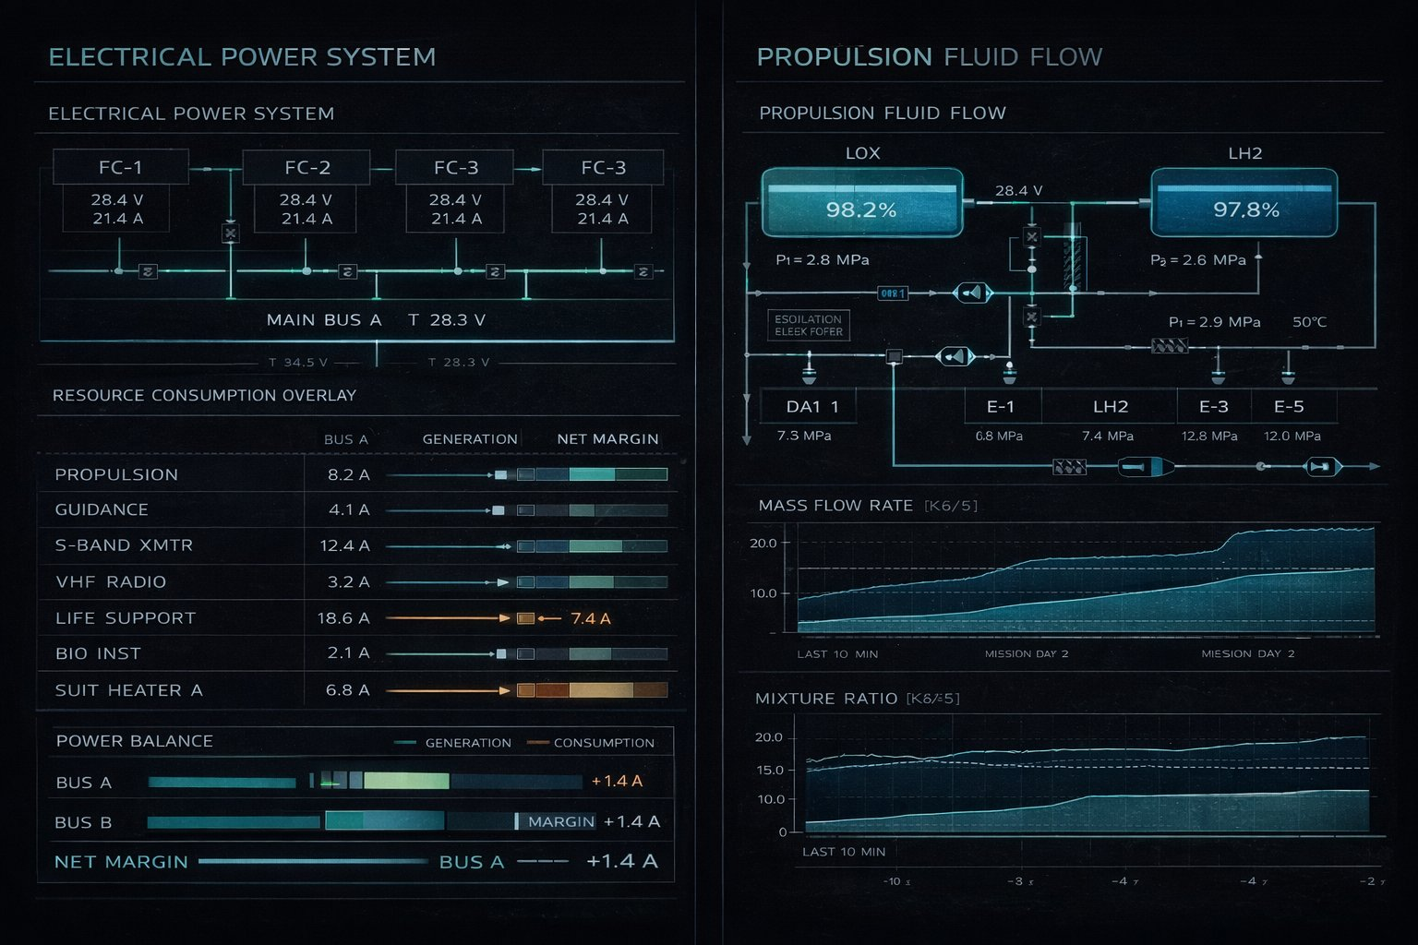

02 FDO — Flight Dynamics Officer
Style guide principles demonstrated: 2D orbital ellipse diagram with Earth at focus · Trajectory deviation bar chart · Dual-axis rolling chart · Abort authority panel · Parameter row data format
Reference sections: Sections 2.1, 3.1, 5.1, 12.4
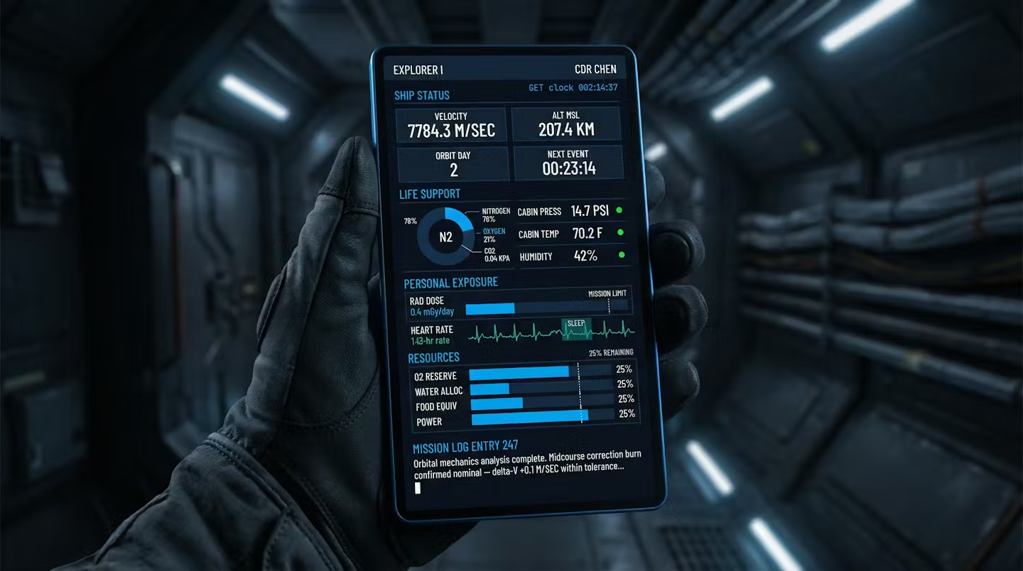

03 EECOM — Electrical Environmental Consumables
Style guide principles demonstrated: Power flow block diagram with live/warning line coding · Environmental trend chart · Consumables vertical bar chart · Power budget donut chart · HEATERS caution in amber
Reference sections: Sections 3.1, 3.5, 5.1, 5.2, 12.4
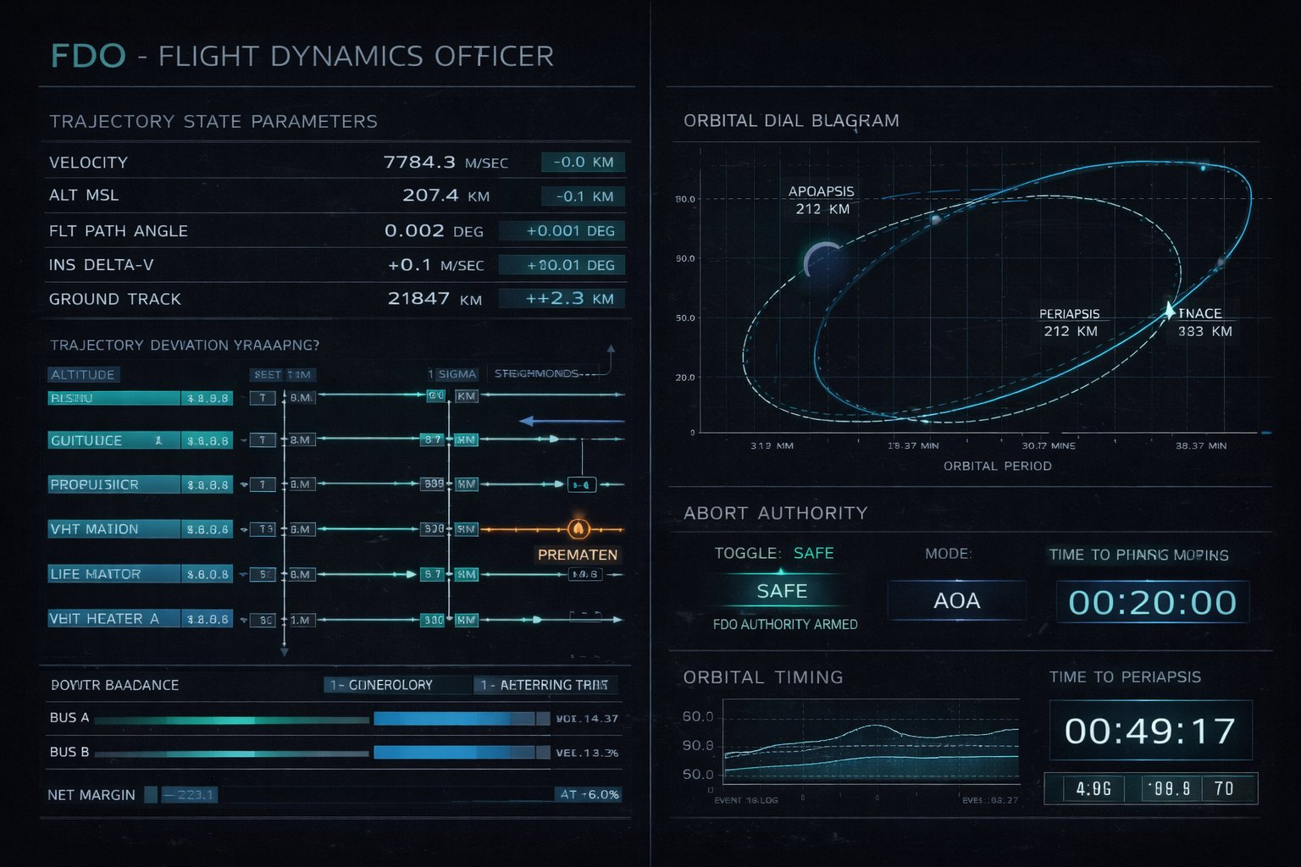

04 BOOSTER — Launch Vehicle Console
Style guide principles demonstrated: Vehicle side elevation schematic · Thrust vs time line chart · Dynamic pressure curve with MAX-Q amber marker · Staging timeline · ABORT AUTH ARMED alarm in red
Reference sections: Sections 3.1, 3.5, 5.2, 7
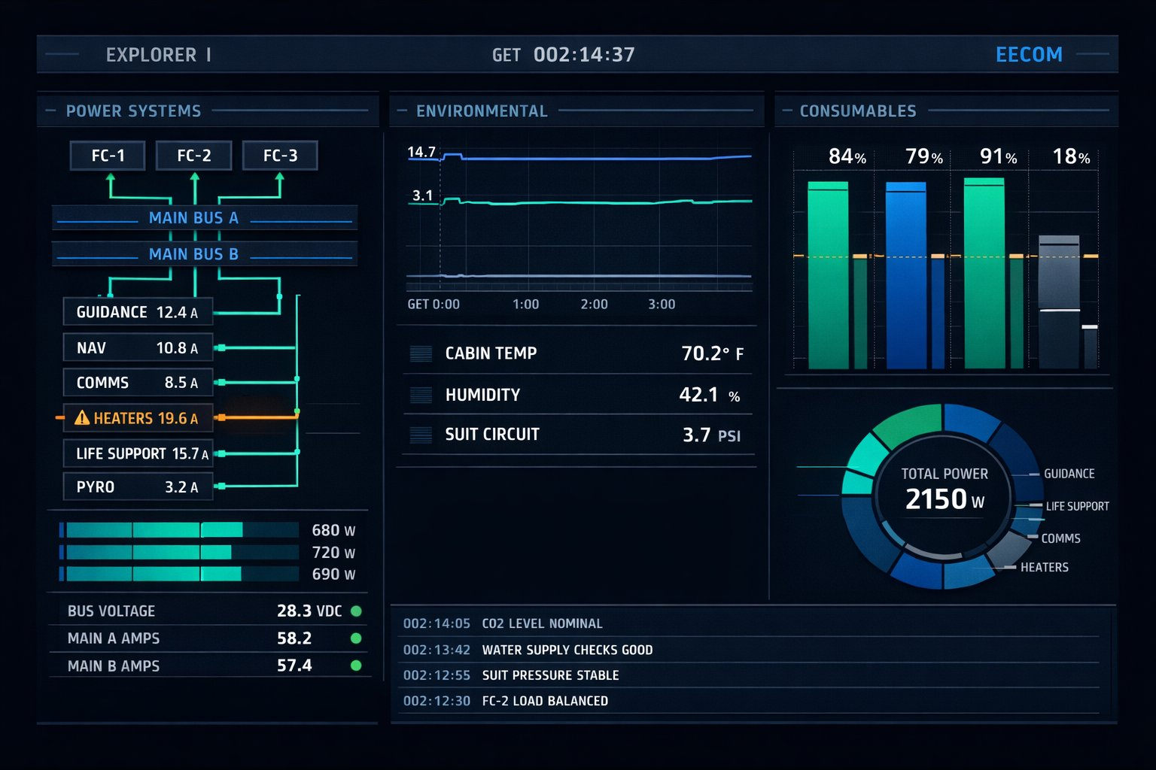

05 GUIDO — Guidance Computer Console
Style guide principles demonstrated: The Expanse dark military palette · 3-axis state vector indicator with PGNCS/AGS divergence · IMU gimbal lock arc gauge · Computer health matrix · Navigation error time series · Kalman filter residuals histogram
Reference sections: Sections 3.3, 5.1, 9.1
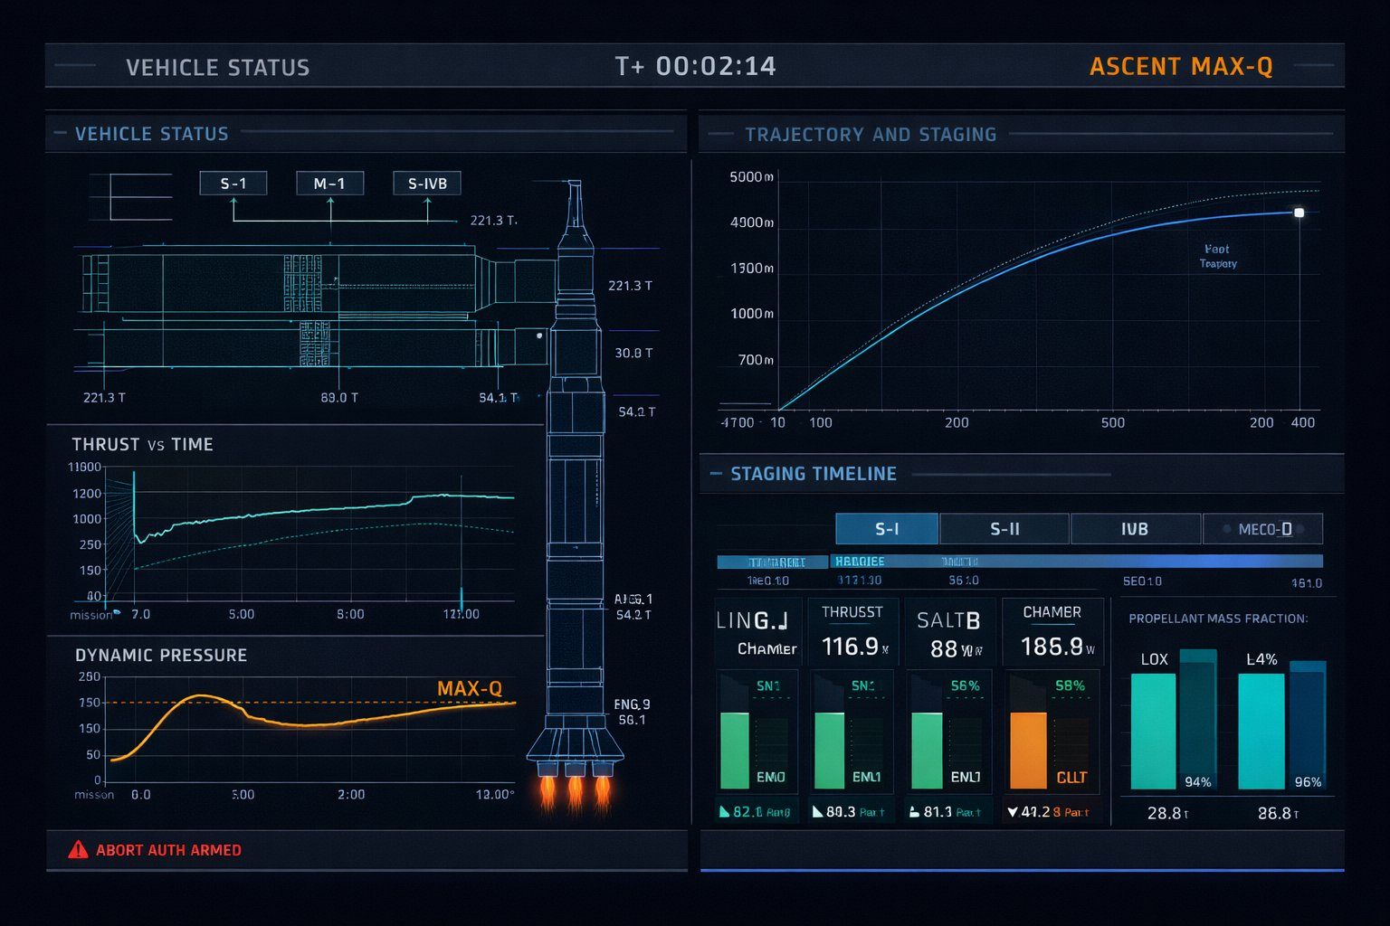

06 RETRO — Retrofire Officer
Style guide principles demonstrated: HABitat light research aesthetic — correctly distinct from dark bridge displays · World map with landing zone ellipses · Entry corridor safety diagram · Heating rate filled area chart · Return timeline
Reference sections: Sections 2.2, 3.2, 9.2
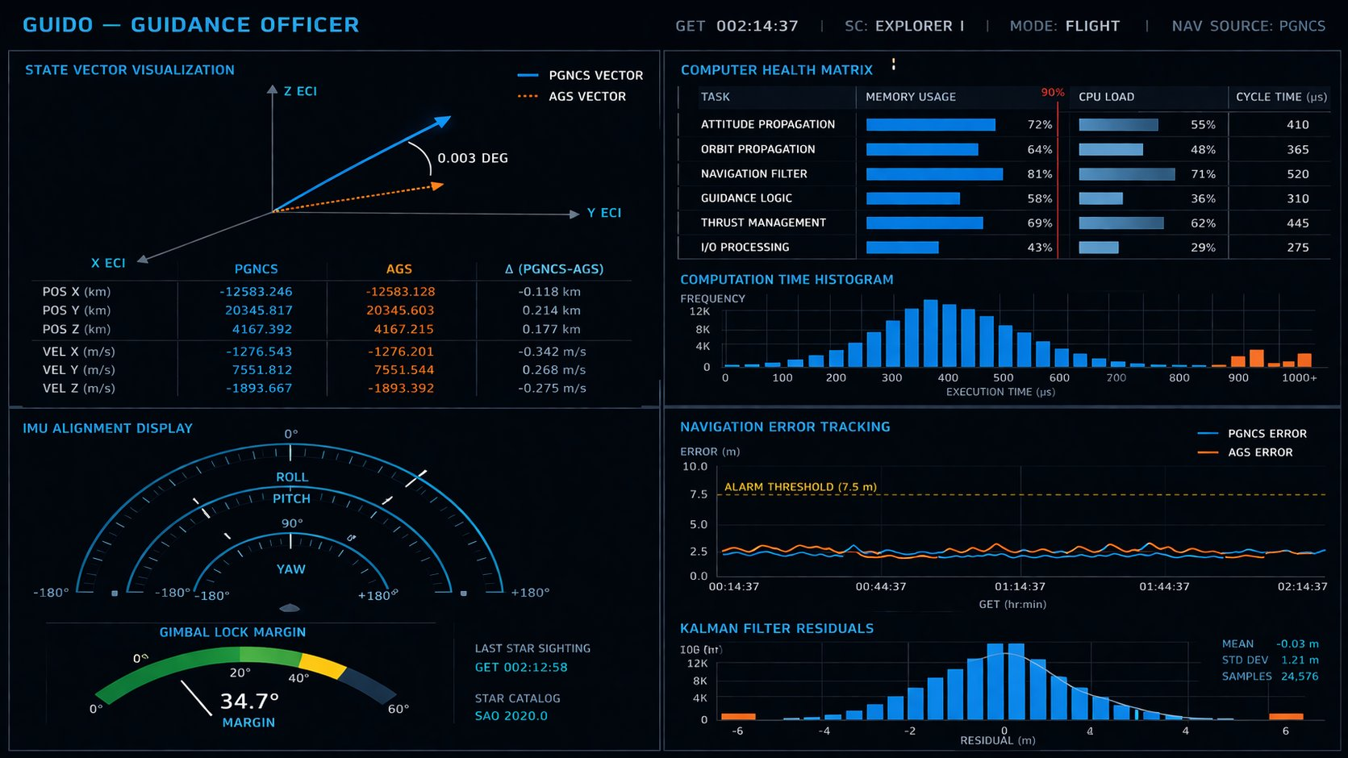

07 SURGEON — Flight Surgeon
Style guide principles demonstrated: Clinical light palette matching RETRO · ECG waveform traces per crew member · 24-hour heart rate trend charts · CAUT state correctly highlighted in amber · Radiation dosimetry bars · Sleep cycle histogram · Exercise log
Reference sections: Sections 3.2, 3.5, 5.2, 7
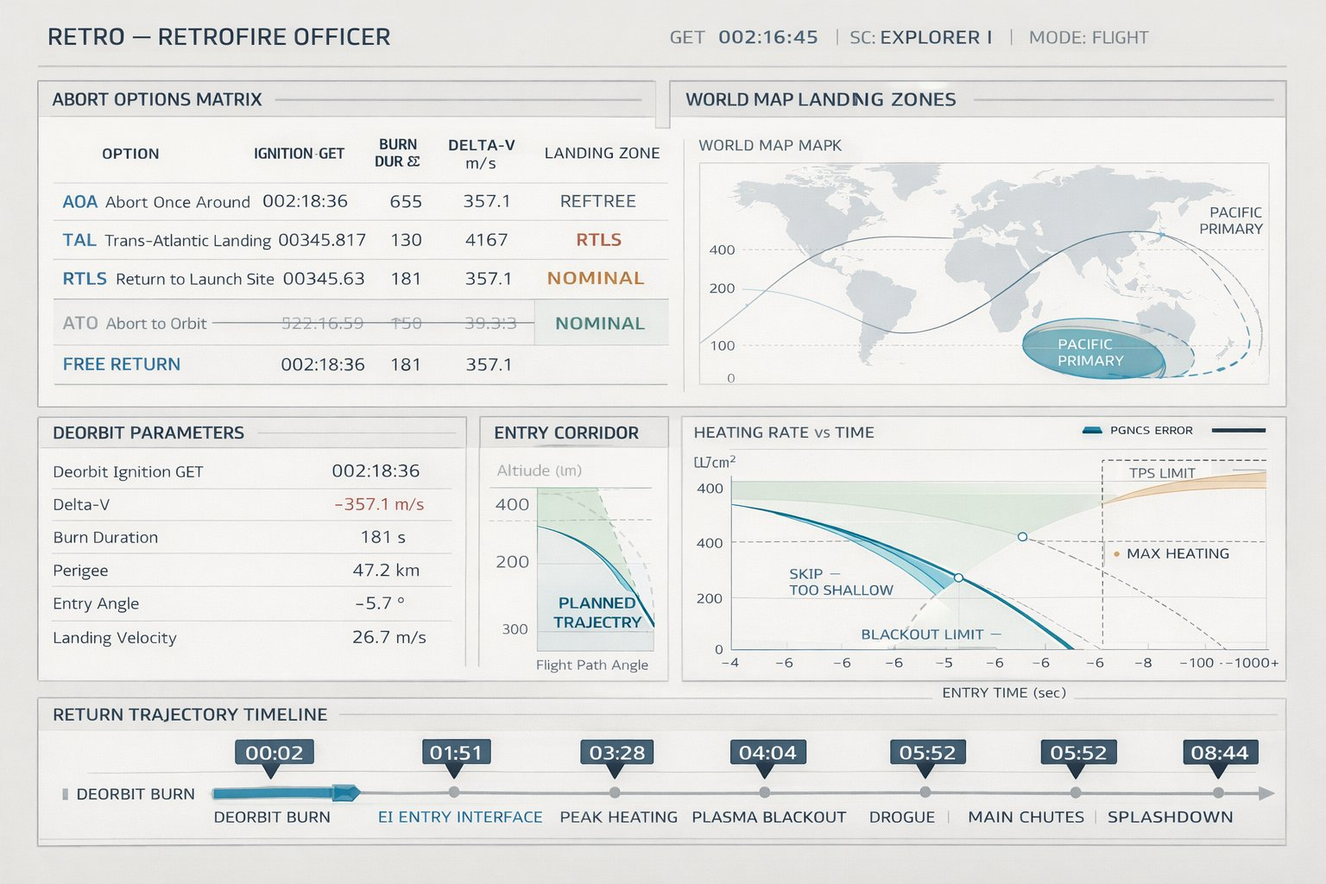

08 CAPCOM — Spacecraft Communicator
Style guide principles demonstrated: The Expanse dark panel aesthetic · Polar projection network coverage map with footprint arcs · Signal quality line chart · Voice routing matrix · Crew activity Gantt swim lanes · Comm pass timeline
Reference sections: Sections 3.3, 5.1, 9.1
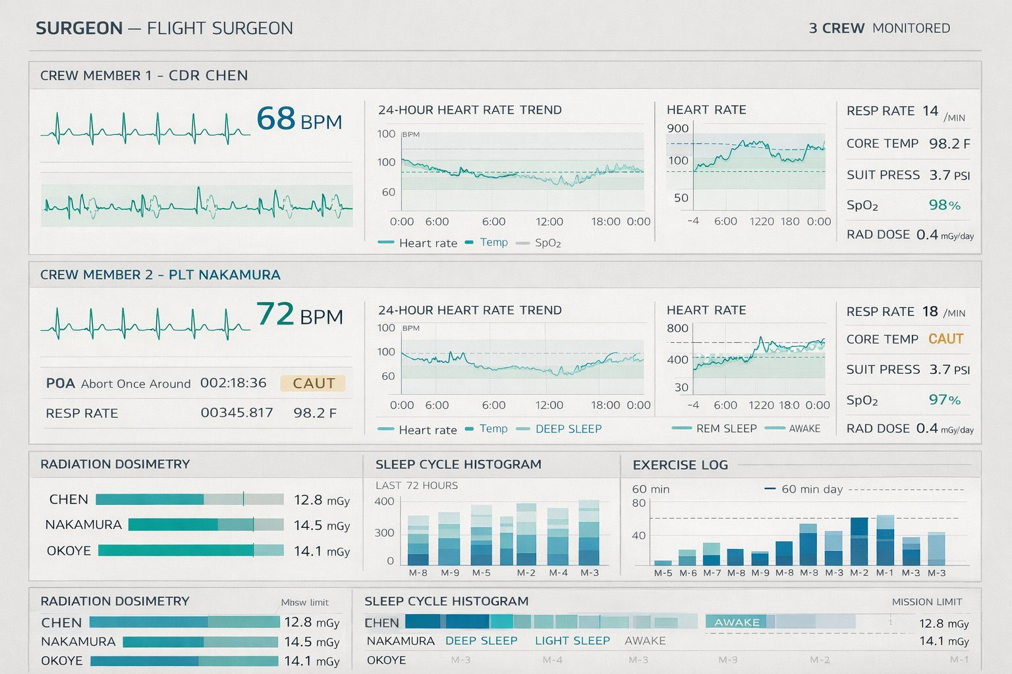

09 Orbital Planning — 3D Holographic
Style guide principles demonstrated: The Expanse holographic spatial display — standout image · Earth as solid navy sphere · Primary orbit in blue with vehicle position and velocity vector · Target orbit in teal dotted ellipse · Maneuver node in orange with delta-V label · Faint spatial reference grid · Operator hands at display edge
Reference sections: Sections 3.3, 8, 9.1
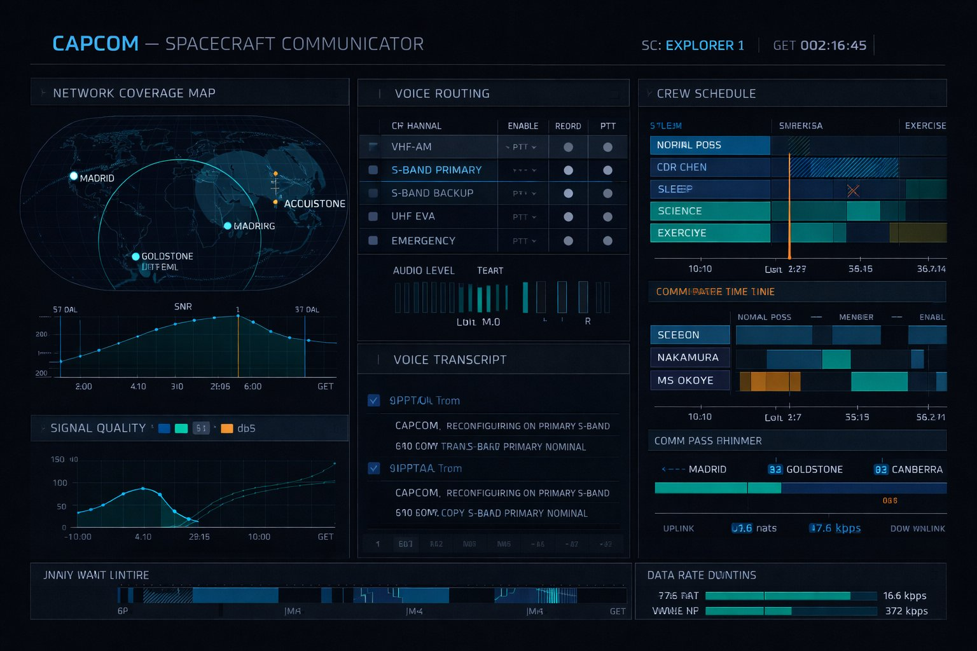

10 Crew Personal Tablet
Style guide principles demonstrated: Expanse handheld device aesthetic — sleek dark glass · Consistent with bridge palette · Note: this screen requires a dedicated generation pass
Reference sections: Sections 3.3, 9.2
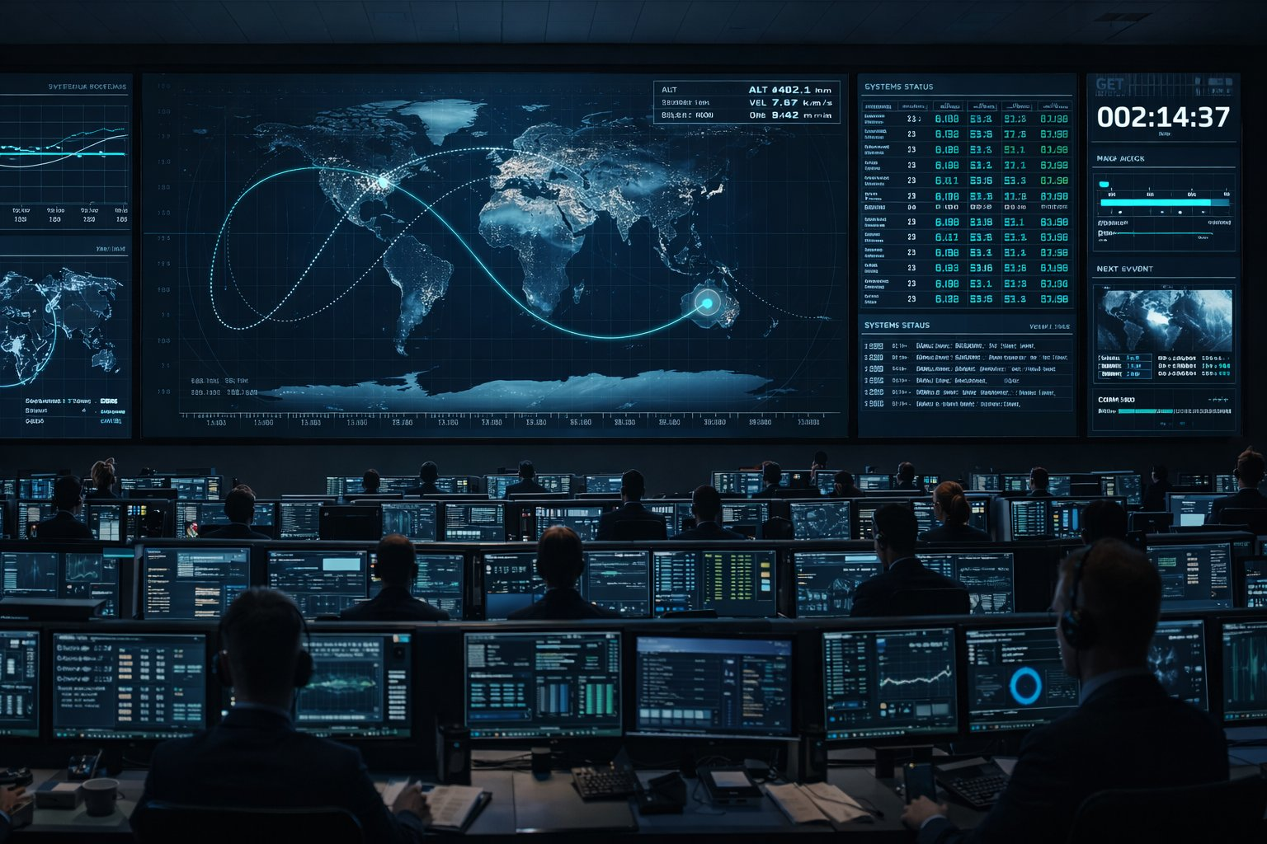

11 Pre-Launch — Pad Status
Style guide principles demonstrated: T-000:08:22 countdown in large modern numerals · LAUNCH STATUS: GO in green · All-stations GO/NO-GO poll grid · Systems health matrix · Propellant loading bars · Vehicle mass donut chart · Weather radar sweep
Reference sections: Sections 3.1, 3.5, 5.1, 5.2
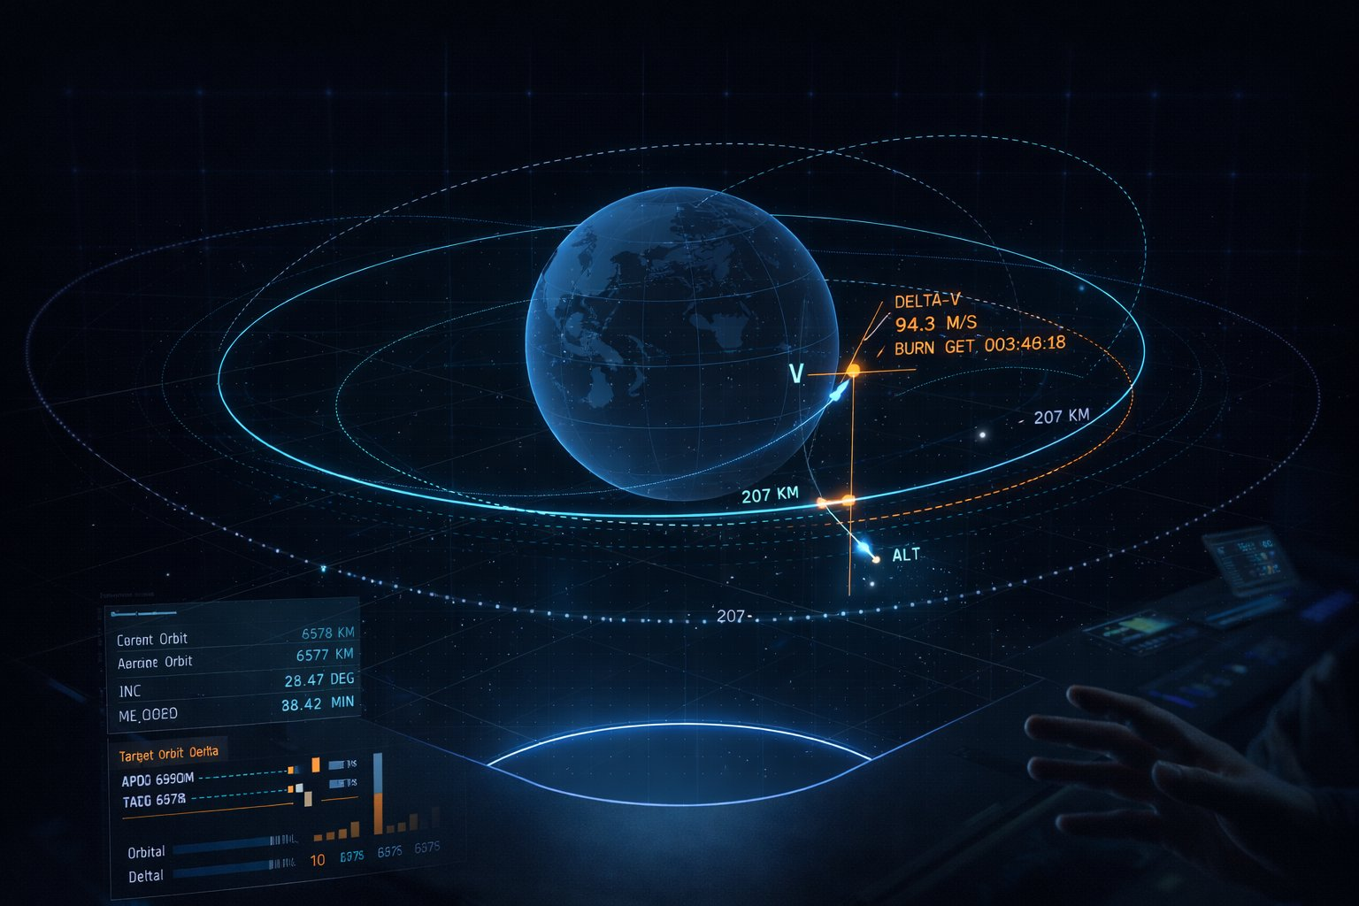

12 Payload & Science Console
Style guide principles demonstrated: JPL engineering maximum density · Spectrometer wavelength chart with O2/H2O absorption features · Imaging coverage footprint map · Storage vertical bar chart · Downlink schedule timeline with station blocks · Cumulative data volume area chart
Reference sections: Sections 2.1, 3.1, 9.2
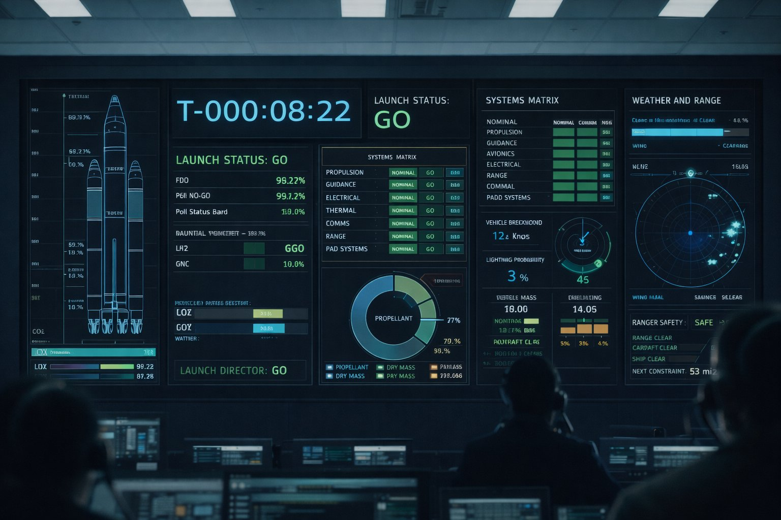

13 Mission Timeline
Style guide principles demonstrated: Wide-format analytical reference · Master horizontal timeline with NOW cursor · Crew activity swim lanes · Critical event in orange · Systems health heatmap grid · Upcoming events readiness table with go/no-go dots
Reference sections: Sections 2.1, 3.1, 8
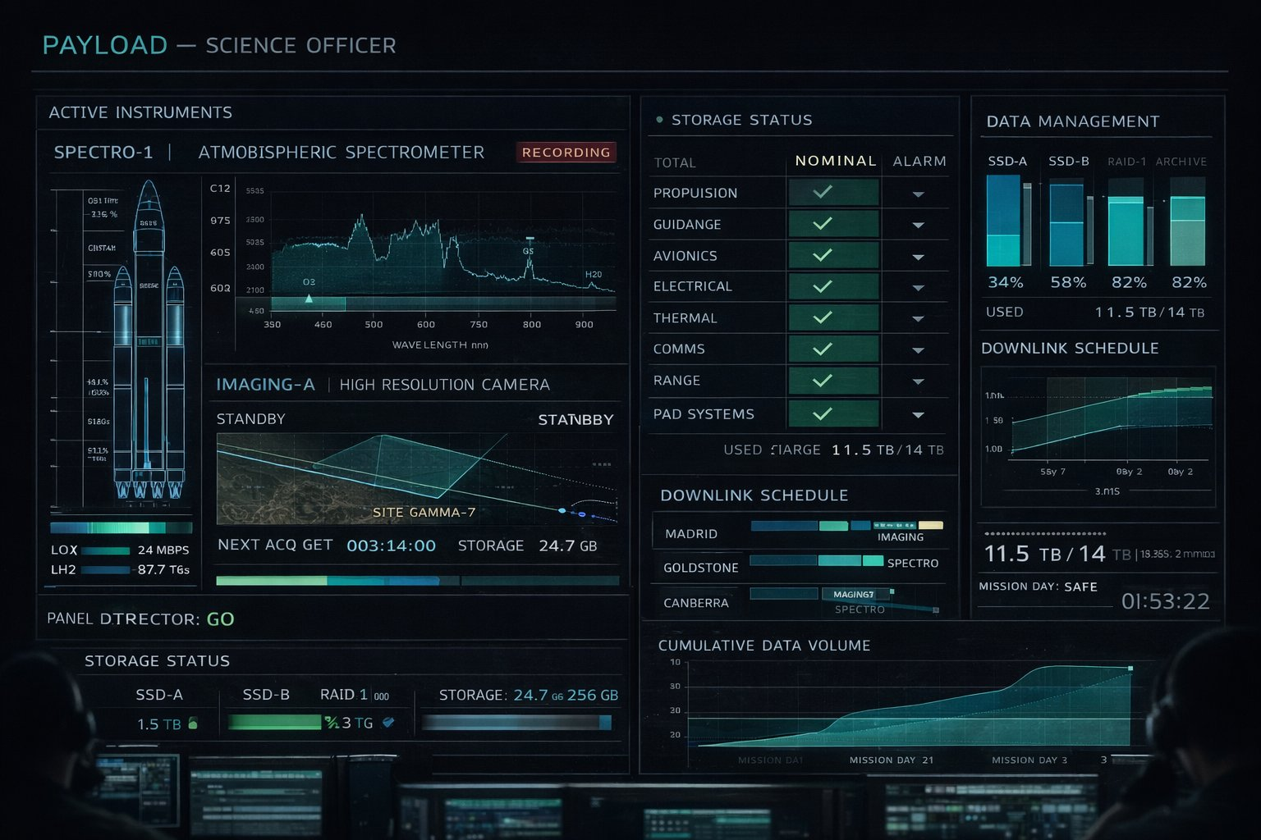

14 Engineering Schematics
Style guide principles demonstrated: Live/dead line color coding in electrical diagram · FC-1/2/3 to bus bars · LIFE SUPPORT in amber caution · LOX/LH2 propulsion fluid schematic with valve symbols · Mass flow rate and mixture ratio line charts · Pure schematic quality — zero decoration
Reference sections: Sections 2.1, 3.1, 3.5
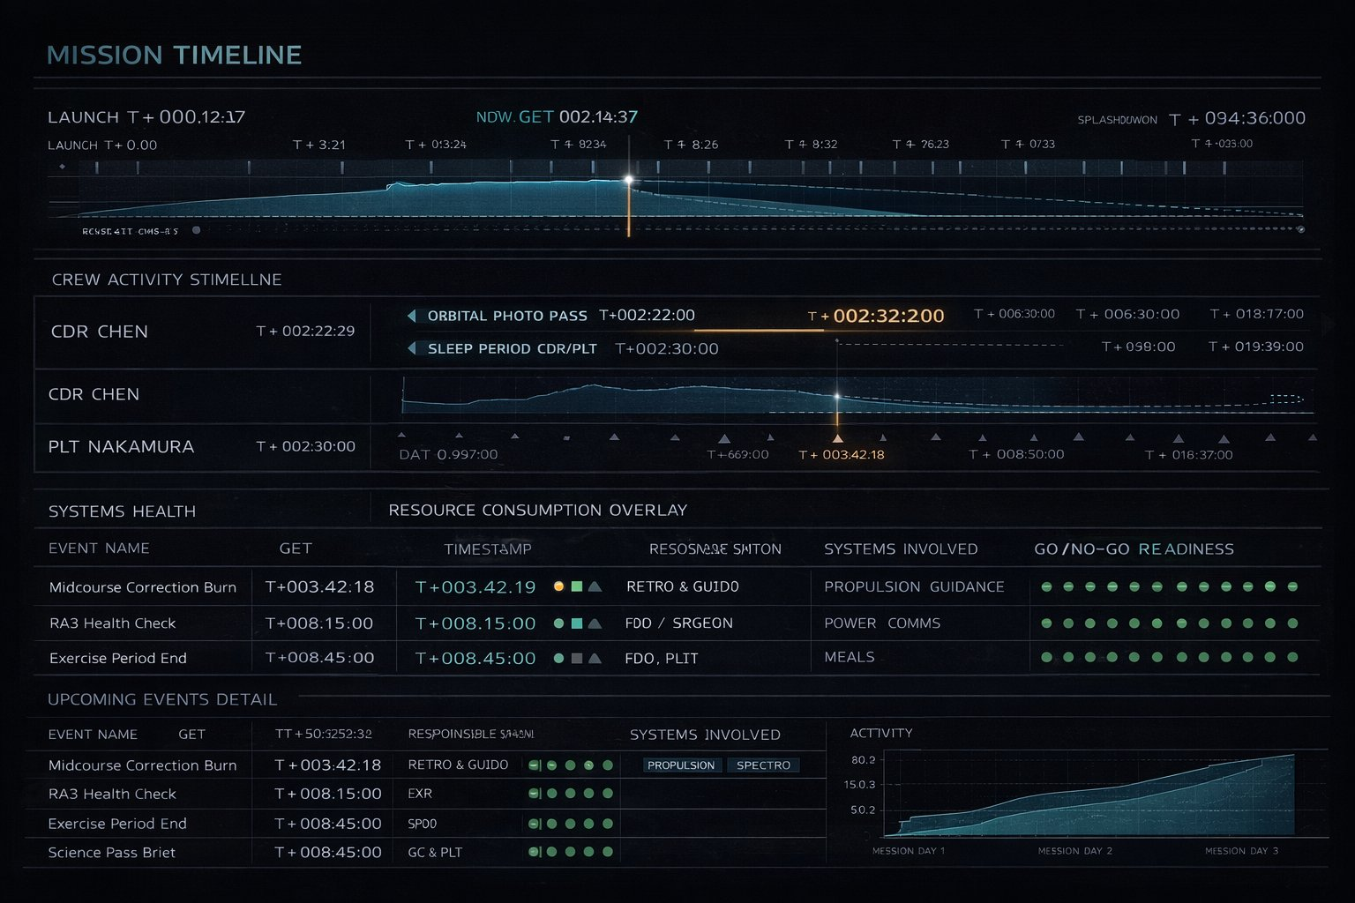

Sources & References

Primary Research
- Territory Studio — The Martian project page: territorystudio.com/project/the-martian/
- Pushing Pixels — Interview with Marti Romances and David Sheldon-Hicks (January 2016)
- AWN / VFXWorld — "Interfacing with Mars: Territory Studio and The Martian" (November 2015)
- HUDS+GUIS — The Martian UI Design analysis (August 2015)
- HUDS+GUIS — The Expanse UI Design with Rhys Yorke interview (May 2021)
- Pushing Pixels — Interview with Timothy Peel, The Expanse Season 1 (January 2016)
- Fuzzy Math — "Sci-Fi UI: What Three Spaceships Can Teach Us" (2025)
- ArtStation — Rocinante UI (Expanse design guides, multiple contributors)
- NotebookCheck — "Project Hail Mary makes a strong case for physical buttons" (March 2026)
- Hackster.io — "Recreating a Cockpit Control Console From Project Hail Mary" (March 2026)
- Fonts in Use — The Martian UI Graphics typeface documentation
- Ars Technica — "Apollo Flight Controller 101: Every Console Explained" — Lee Hutchinson (2019)

Icon Libraries
- Lucide Icons: lucide.dev — ISC License
- Phosphor Icons: phosphoricons.com — MIT License
- Tabler Icons: tabler.io/icons — MIT License

Typography
- Google Fonts: fonts.google.com — Open Font License (all fonts cited in this guide)
- JetBrains Mono: jetbrains.com/lp/mono — OFL
- IBM Plex: ibm.com/plex — OFL

KSA-Bridge Sample Library · UI Style Guide v2.0 · April 2026

